TEMA 9
ACTIVIDADES RECREATIVAS

Son las que generalmente hacemos en nuestro tiempo libre y que de alguna manera disfrutamos haciendolas.

VOCABULARY
CHOOSE THE CORRECT WORD.
* Check

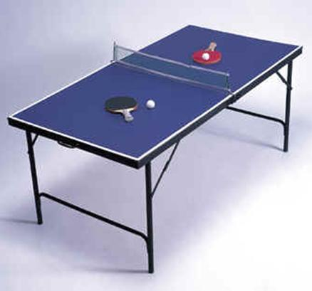
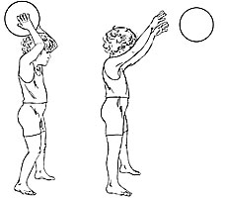
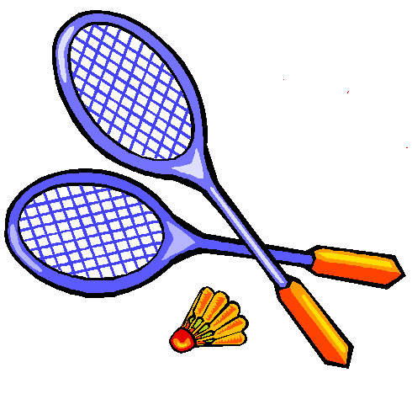
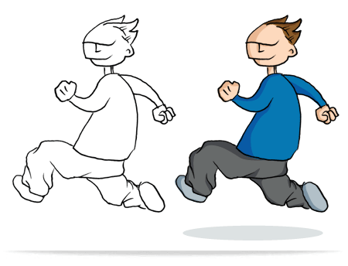
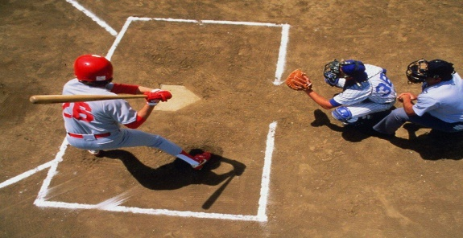
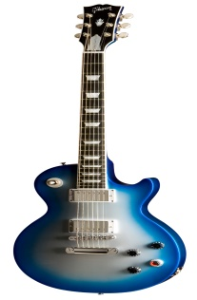
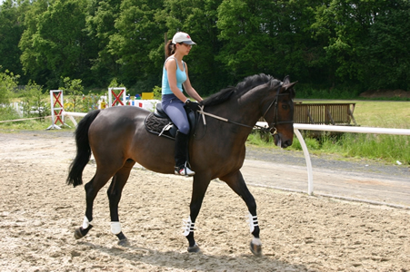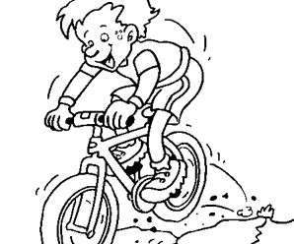
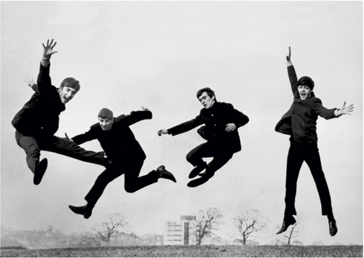
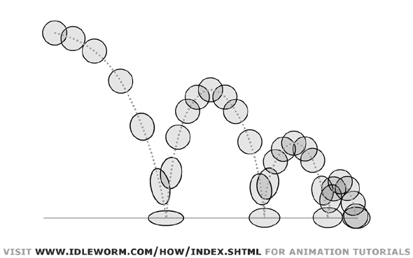

I

WRITE SENTENCES USING THE FOLLOWING PHRASES
1.-watch TV 6.- play computer games
2.-read comics 7.- ride my bike
3.-Go to dance class 8.- play volleyball / basketball
4.- take the dog for a walk 9.- go out with friends
5.- go to the park 10.- go to the gym

1___________________________________________________________________________________________________
2.___________________________________________________________________________________________________3.___________________________________________________________________________________________________4.___________________________________________________________________________________________________5.___________________________________________________________________________________________________6.___________________________________________________________________________________________________7.___________________________________________________________________________________________________

SIMPLE PRESENT AUX: DO /DOES
I DO HE DOES
YOU DO SHE DOES
WE DO IT DOES
YOU DO
THEY DO

Presente simple
Para realizar preguntas en este tiempo verbal, se usa el auxiliar DO o DOES para la tercera persona del singular, como ya hemos visto. Y se contesta con Yes / No seguido de la persona y su auxiliar correspondiente afirmativo o negativo.
Yes / No questions

do I play very well? Yes, you do / no, you don’t
do you play very well? Yes, I do / no, I don’t
does he play very well? Yes she does / no, she doesn`t
does she play very well? Yes she does / no, she doesn’t
does it play very well? Yes, it does / no , it doesn’t
do we play very well? Yes, you do / no, you don’t
do they play very well? Yes, they do / no, they don`t

Write do or does on the line Escribe “do” o bien “ does “ según corresponda

Write do or does en el espacio vacío
1) ________Peter live with his father?
2) ________ you learn Spanish?
3) ________ Andrew and Martin ride their bikes to school?
4) ________ they play in the garden?
5) ________ Sandy's hamster live in a cage?
6) ________ the cats sit on the wall?
7)________ we work in front of the computer?
8) ________ you play the drums?
9) ________ Steve wear pullovers?
10)________ I clean the bathroom?

Activity 2.- ordena las siguientes oraciones
1. you / get / what / time / up / do ?_____________________________________
2. Julia / does / alone / live ?__________________________________________
3. does / come / the / bus / what / time ?________________________________
4. have / you / every / breakfast / day / do_______________________________

VERBOS I LIKE + ING
Cuando estas palabras (love, like, dislike, hate) van seguidas de verbos se les agrega ing.
a) Verbo + ing
-She loves listening to music. (Me encanta escuchar música)
-I like playing soccer. (Me gustan jugar futbol)
-He doesn’t like eating vegetables. (A él no le gusta comer verduras/vegetales)
-He dislikes eating bread. (A él no le gusta comer pan)
-They hate dancing. (Odian bailar)
-

EXPLICACION: C
Like / Love / Not like / Hate/ Prefer + Activities

like | love | not like | hate

LIKE NOT LIKE
I +  you  we  they | like + | verb -ing | I +  you  we  they | don't + | verb -ing
he / she + | likes + | verb -ing | he / she | doesn't + | verb -ing

Verbs + -ing
dance | dancing
ride | riding
ski | skiing
run | running
swim | swimming

dance do homework draw do nothing listen to music play computer games play football play rugby

play tennis play the guitar read ride a bike ride a horse run sing ski

play games do sport surf work swim

Make sentences.

I + + She + + He + +
I love singing. She doesn't like doing sport. He hates dancing.

She + + I + + We + +
. . our .

They + + He + + I + +
. . .

You + + I + + She + +
. . .

He + + I + + They + +
. . .

We + + She + + He + +
. . .

We + + She + + They + +
. . .

You + +
.

Link to this exercise from your website or blog:
Cuando usamos el verbo “like, hate, love or prefer“ y la siguiente palabra es un verbo le vamos agregar ing al verbo
SUBJECT + LIKE + VERB-ING - COMPLEMENT
Susan likes eating vegetables everyday
SUBJECT + HATE + VERB +ING –COMPLEMENT
They hate working at night
SUBJECT + PREFER + VERB-ING - COMPLEMENT
The children prefer working in groups during the in class.
SUBJECT + LOVE + VERB-ING - COMPLEMENT
Peter loves watching horror movies.

Subject- like + (noun)
También podemos usar el verbo “like” con un sustantivo
Here are some examples:
"I like a balloon."
"I like a jellyfish."
"I like a banana."
"I like fish."

CONTESTA EL SIGUIENTE EJERCICIO YA SEA SUSTANTIVO O VERBO
Noun or verb? - Exercise
Decide whether the word in bold is a noun or a verb. Match all the items on the right with the items on the left.
1) I like your computer. -
2) We live in a small town. -
3) They play handball. -
4) His friend has a pet. -
5) I go to bed at 9 o'clock. -
6) My bedroom is upstairs. -
7) Let's listen to this CD. -
8) Sam and Tom watch TV. -
9) They swim in a lake. -
10) I always feed my hamster. -

Direct Objects and direct object pronouns
En Inglés , el,objeto Directo es un objeto el cual recibe la “acción directa de un verbo. Si yo compro un libro, el libro es ek objeto porque es lo que yo compro- Esta siendo comprado.
En Inglés el objeto directo sigue el verbo en una oración en voz pasiva

Let's take a look at an example:
I steal the car.
Now let's examine the components of the sentence.
I | This is the subject of the sentence - the person in charge of the verb.
steal | This is the verb (and as a transitive verb, it transfers action to an object and so requires an object)
the car | this is the direct object (it receives the action of the verb): The car is what I steal. The car is what is being stolen.
Now replace the Direct Object [the car] with a Direct Object Pronoun [it]:
I steal it.
"It" is a direct object pronoun ("it" refers to what was stolen - in this case, a car)

Why do we use a Direct Object Pronoun?
This relieves us from endlessly repeating the Direct Object itself:
I pick up the book. I look at the book and decide to buy the book.
vs.
I pick up the book. I look at it and decide to buy it.

Now let's look at the same sentence in Spanish:
Yo robo el carro.
Again, let's examine the components of the sentence.
Yo | = the subject
robo | = transitive verb
el carro | = the direct object
- Now we replace the Direct Object [un carro] with a Direct Object Pronoun [lo].
- We use lo because carro is masculine and singular. Lo = it (un carro) [See the chart below for all of the direct object pronouns.]
- * Yo robo [lo].

Direct Object Pronoun Placement (applies to all pronouns)
- In Spanish you must place the direct object pronoun directly in front of the active (conjugated) verb when you only have one verb: Yo lo robo.

- When we have compound verbs (two verbs) we can always put it directly in from of the conjugated verb: (Yo) lo voy a robar;
  - But since we have two verbs, we have two options. We can attach the pronoun to the end of an infinitive or a present participle:
    - Yo estoy robándolo. (present participle)

- Pronouns can also be attached to Affirmative commands- click here for information on commands and pronouns.
  - Róbalo [Affirmative Command]
We can never place an object or object pronoun between the elements of compound verbs or verb phrases:
*Voy a lo hacer nor *Tengo lo que hacer.

The Direct Object pronouns:
Yo | me | nos | Nosotros
Tu | te | os | Vosotros
Él, Usted (male)  ["it" masculine] | lo | los | Ellos, Ustedes  ["those things" masculine]
Ella Usted (female)  ["it" feminine] | la | las | Ellas, Ustedes  ["those things" feminine]

