Search All NYTimes.com

Art & Design
- World
- U.S.
- N.Y. / Region
- Business
- Technology
- Science
- Health
- Sports
- Opinion
- Arts
  - Art & Design
  - Books
  - Dance
  - Movies
  - Music
  - Television
  - Theater
  - Video Games
- Style
- Travel
- Jobs
- Real Estate
- Autos
Advertise on NYTimes.com

Architecture Review

Nostalgia Wrapped In Steel
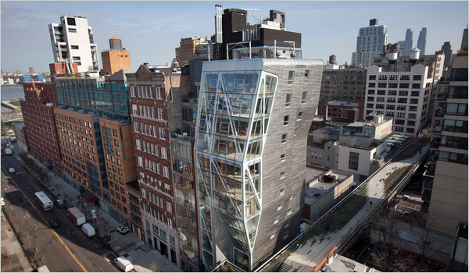
Michael Falco for The New York Times
The bulging glass south facade of Neil Denari’s 14-story HL23 condominium tower has an aerodynamic look and swells as it rises over the High Line in west Chelsea.

By NICOLAI OUROUSSOFF

Published: April 25, 2011
Architecture is a notoriously slow profession. Mastering all the elements that go into designing a building — scale and context, material and form, the structure needed to hold the building up — takes a lifetime. And clients investing millions of dollars in a project tend to feel safer around someone with a little gray around the temples.

Blog

ArtsBeat
The latest on the arts, coverage of live events, critical reviews, multimedia extravaganzas and much more. Join the discussion.
- More Arts News
Enlarge This Image
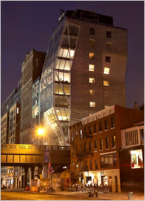

Michael Falco for The New York Times
The new 14-story residential building in Chelsea overlooks the soon to be opened extension of the Highline Park on West 23rd Street.
Enlarge This Image
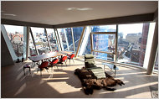

Michael Falco for The New York Times
A varied sequence of interior spaces overlook the High Line.
Enlarge This Image
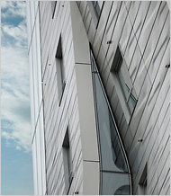

Rinze Van Brug.
The tower's long vertical and tilted windows.
But even given all that, the pace of Neil Denari’s career seems excruciatingly slow. This architect, born in Texas, who founded his firm in 1988, has been a prominent figure in architectural circles since the late 1990s, when he was director of the Southern California Institute of Architecture, an offbeat school that was a center of experimentation. Since then, although he has remained a prominent academic — he is now a professor at the University of California, Los Angeles — he has done only a handful of small additions and renovations. He has never produced a free-standing building.
So the completion of HL23, a 14-story condominium tower at 10th Avenue and 23rd Street in west Chelsea, is a milestone in the career of one of the country’s most underachieving talents. Encased in a contoured glass-and-steel exterior, the building is as sleek and muscular as an Italian sports car. And it establishes Mr. Denari, at 53, as an architect with something to say about the road American culture has followed from the postwar era to today.
The conditions for the project were not ideal. The building stands on a relatively small (12,000-square-foot) lot, almost two-thirds of which is tucked beneath the elevated greenway of the adjacent High Line, making it impossible to build on. The rest is wedged between a residential tower on one side and the High Line’s bulky steel frame on the other.
To pack the maximum square footage into such an awkward space, Mr. Denari designed a building that swells as it rises. Seen from 23rd Street, the building’s bulging glass south facade has an aerodynamic look. Seen from the High Line, the folded steel surface of its eastern side — whose panels were manufactured in Argentina on presses used to make body parts for Mercedes trucks — conjures a hood scoop on a car.
The building’s odd form creates a wonderfully varied sequence of interior spaces. The lower apartments overlook the High Line’s gardens through floor-to-ceiling windows that resemble enormous windshields. From a south-facing fourth-floor living room, you look straight down the length of the High Line’s concrete walkways and gardens, which veer off to the left before disappearing behind a building several blocks away. (The effect is especially mesmerizing at night, when the High Line is closed to the public and evokes an abandoned road, overgrown with wild flowers; during the day, when it is mobbed with people, the experience is more voyeuristic.)
The mood changes higher up, where the building expands to accommodate bigger floor plates. Tilted glass walls in a sixth-floor living room allow residents to look straight down into the High Line’s luxurious gardens. A seam in the building’s east facade creates a long vertical window with views north up the elevated park, which from this height looks like a highway.
The machine aesthetic is everywhere. Steel cross braces cut across the windows. Many of the glass walls are mechanized, sliding open a few inches at the touch of a button.
The allusions to a mobile culture suggest a version of the American dream straight out of the Eisenhower era. And even the building’s voyeuristic aspects can be read as a form of nostalgia: a Manhattan version of teenage lovers steaming up car windows parked on a cliff side overlooking the bright lights of the city below.
But like other architects of his generation, especially those who formed many of their ideas working in Los Angeles’s sprawling suburban maze, Mr. Denari is less interested in perpetuating the myth of the open road than in mining it for new ideas. His work has more to do with exploring adolescent fantasies than with celebrating personal freedom. It suggests a longing for a world — free, open, upwardly mobile — that began to break down more than 30 years ago.
In Chelsea Mr. Denari has created a building that, intentionally or not, is as much about the desire to recapture that vision of America as about the pretty views. Inevitably, it makes you wonder where that dream went wrong.

A version of this review appeared in print on April 26, 2011, on page C1 of the New York edition with the headline: Nostalgia In Glass And Steel.
- Sign In to E-Mail
- Print
- Reprints
Connect with The New York Times on Facebook.

